# Tutorial 6 for submission

**Submitted by**

**Sabbir Hasan Rabbi**

**Id: k240175**

**Here are the errors and issues that I have corrected in the code:**

1. **Extra Semicolon**: There is an extra semicolon after `**package lab06**`.

2. **Class Naming Convention**: Java class names should follow the PascalCase convention. ‘gradereport` to `GradeReport`.

3. **Scanner Import**: The `Scanner` class is used but not imported.

4. **Variable Naming Consistenc**: The array is declared as `Scores` but referenced as `scores` in the code.

5. **Method Name**: The method `in.nextdouble()` should be `in.nextDouble()`. Method names are case-sensitive.

These are the errors which I corrected in the code and attached the code file in submission.

**programming standards I implemented to the codes :**

* **Beginning Comments**: I added some comments along with beginning comment which ia a standard to follow for reliable source code.
* **Left and Right braces :** aligned the braces accordingly.
* **White Space (Blank Lines) :** Used whitespace in methods ad logical sections.
* **One declaration per line :** several lines were in one line, added them in different lines.
* **Compound statements :** added braces in if-else following the rules.
* **Naming Convention standards** : followed appropriate naming conventions**.**

1. **In Airline.java from Moodle and document here is the two different test cases given below, I also attached the screenshot after running the program.**

|  |  |  |  |  |
| --- | --- | --- | --- | --- |
| Test case ID | Test case | Test Data | Expected Outcome | Actual Outcome |
| 01 | Check eligibility for a passenger under the age of 6 | Mike Tyson  40 | Passenger name: Mike tyson  Passenger age : 40  This passenger is not eligible for a 25% discount. | Passenger name: Mike tyson  Passenger age : 40  This passenger is not eligible for a 25% discount. |
| 02 | Check eligibility for a passenger under the age of 6 | Reyhna  04 | Passenger name: Reyhna  Passenger age : 4  This passenger is eligible for a 25% discount.  . | Passenger name: Reyhna  Passenger age : 4  This passenger is eligible for a 25% discount. |

**Output for the ID 01:**

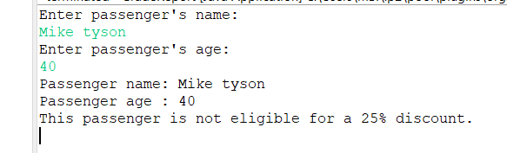

**Output for the ID 02:**

